

**Business Requirements Document**

**CPS-Tec Migrate FIDs SAPUF to Cyberark Block 2**

Version: Version 1.8

Date: 09/03/2020

Lead Business Analyst: Martinez Ramirez, Alejandro [CCC-OT]​ (AM47114)

Business / Operations Sponsor: Haua, Claudia [GCB-OT] (CH76667)

Sponsor Organization: Sztabnik, William [CCC-OT] (WS22453​)

BA Authors: Vega Olvera, Sukey [CCC-OT] (SV07571)

Planview Number: P0149779

Target Release: 2020-08-Wk4

Work Request ID: X-1788602

This page displays the U.S. Export Notice. Do NOT delete.

**US Export/Reexport Notice**

Any transfer of this information beyond a country’s border (or release to others in country knowing they are foreign nationals* or will transfer the information cross border) may require the prior approval of the U.S. Government as well as the country where it is located.  To ensure compliance with applicable requirements, please contact your local Export License Coordinator (ELC) for assistance: . <https://www.citi.net/EN/Pages/riskmanagement/ContentPages/ECU-Templates-and-Forms.aspx?src=/EN/operationsandtechnology/riskmanagement>. If you are unable to find your ELC please contact the Chief or the Senior ELC.  
*Non Citizen/non permanent resident

**Table of contents**

Template Instructions 5

1 BR Change History 5

2 Project Information 6

**2.1** **General Project Information** 6

3 Scope Statement 7

**3.1** **Project Description/Objectives \*** 7

3.1.1 **Project Description/Objectives** 7

3.1.2 **Non-Financial Benefits \*** 7

3.1.3 **Method for Measuring Benefits \*** 7

**3.2** **Justification** 7

**3.3** **Assumptions \*** 7

**3.4** **Constraints \*** 7

**3.5** **Dependencies \*** 8

**3.6** **Acceptance Criteria * (Critical Success Factors)** 8

**3.7** **Impacted Portfolios** 8

**3.8** **Scope \*** 8

4 Features 9

5 Business Requirements Information 10

**5.1** **Business Process Diagrams** 10

**5.2 Business Rules** 11

5.2.1 **Business Rule** 11

**5.3** **Business Requirements \*** 11

5.3.1 **Business Functions and Process Descriptions \*** 11

5.3.2 **Business Requirements (1..n) \*** 11

**5.4** **CITMS Mandatory Business Requirements \*** 11

5.4.1 **Reporting \*** 11

5.4.2 **Interface \*** 11

5.4.3 **Legal, Regulatory, Compliance, Anti-Money Laundering and Records Management Requirements \*** 11

5.4.3.1 Accessibility Requirements 12

5.4.4 **User Testing Requirements \*** 12

5.4.5 **COB Recovery Requirements \*** 12

5.4.6 **Data Transfer \*** 12

5.4.7 **List of UAT Stakeholders (Organizations which will perform UAT) \*** 12

5.4.8 **Perform Production Parallel Testing \*** 13

5.4.9 **Perform Production Assurance Testing (PAT) \*** 13

5.4.10 **Data Requirements \*** 13

5.4.11 **Are there any Cross Border Data Privacy Implications with this project? \*** 13

5.4.12 **Security Requirements** 14

**5.5** **Business UI Screens** 15

**5.6** **Other Business Diagrams** 16

6 Glossaries 16

**6.1** **Glossary of Acronyms** 16

**6.2** **Glossary of Terms** 16

# Template Instructions

The following template provides instructions that should be removed before finalizing the document including this section.

Instructions for Technology Mandatory projects: If your project is a technology mandatory project without any impacts to the application or it’s functionality, a template is available on the Blueprint Support Sharepoint site to assist you with filling out the necessary information: <https://consumershare.nam.citi.net/sites/GCTBPSUP/Document%20Templates/Forms/AllItems.aspx>

# BR Change History

| Name | Date of change | Owner of change | Description |
| --- | --- | --- | --- |
| New BR History 1 | Pending | Jena, Nilasundar [GCG-NAOT] | The BR History folder contains information about changes to business requirements after approval.  (Artifact Type: Folder)  BR History is added to the BR History folder when changes are made after approval.  A BR History artifact should be added for each change and must include a description of the change and the PCR numbers associated with the change. (Artifact Type: BR History) |

# Project Information

## **General Project Information**

BA Authors

| Full Author Name | FR Sections Authored |
| --- | --- |
| Vega Olvera, Sukey [CCC-OT] sv07571 | All |

**List of Reviewers**

| ID | ROLE | NAME |
| --- | --- | --- |
| AM47114 | Project CISO Leader Reviewer | Martinez Ramirez, Alejandro |
| PG78733 | PM Reviewer | González Jaramillo, Pedro Enrique |

**List of Approvers**

| ID | ROLE | NAME |
| --- | --- | --- |
| WS22453 | Sponsor/Road map owner | Sztabnik, William [CCC-OT] |

# **Scope Statement**

* 1. **Project Description/Objectives \***

### **Project Description/Objectives**

The objective of the project is to implement the global standard solution named CyberArk to manage in automatic way the passwords between applications and it is aligned with security features that Citi has been defined for manage passwords and it has a support model for the onboarding and BAU activities with global operating teams (GIDA, Security Operations and privileged identity management). And it is available for diverse platforms and versions that Citi has defined as standard solutions.

Objectives:

• Migrate the FIDs administration from Sapuf system to CyberArk

• Adopt the CyberArk global standard

• Eliminate the operational risk posed by not having longer a support contract with current solution provider SAPUF

• Incorporate new functionalities/capabilities to manage functional accounts and security

• Retire Unisys and Tandem SAPUF Agents (suppliers)

• Eliminate SAPUF Core application running in Tandem.

### **Non-Financial Benefits \***

### The project is part of the Core Platform Simplification Program/Mx2020 strategy, therefore the non-financial benefit is about Control/Process Improvement/Simplification

### **Method for Measuring Benefits \***

### Review that the applications are no longer using the legacy Sapuf component in Production.

* 1. **Justification**
     1. **Justification**

SAPUF is the functional ID´s password management system between applications used at Citibanamex, it is based on TANDEM platform, requires manual administration and is based on the legacy nomenclature about applications and it has not been adding functionality and support last platform versions (such operating systems and databases) in the last 5 years.

* 1. **Assumptions \*** 
     1. **Assumptions**

All Citibanamex applications that use SAPUF as mechanism to manage password of functional IDs. It is mandatory that the application is registered in Citi System Inventory (CSI) and the Functional ID is registered into the Central ISA Repository (CISAR).

* 1. **Constraints \*** 
     1. **Constraints**

Applications without vulnerability assessment that can affect the project timeline

Applications that requires performance tests that can affect the project timeline

Time and Date constraints:

August 22nd release.

Resource constraints:

Resources available for the development on the applications

Budget constraints:

There are budget constraints since the funds are already available.

* 1. **Dependencies \*** 
     1. **Dependency**

There are no dependencies. The infrastructure is already available in NAM.

* 1. **Acceptance Criteria * (Critical Success Factors)** 
     1. **Acceptance Criteria**

Inactive FIDs in Sapuf and active FIDs in CyberArk

* 1. **Impacted Portfolios** 
     1. **Impacted Portfolios**

ICG, GCG and CTO impacted portfolios.

* 1. **Scope \*** 
     1. **Scope**

|  |  |  |  |  |
| --- | --- | --- | --- | --- |
| CSI ID | NAME | Sector | SYSTEM TYPE | SYSTEM PLATFORM |
| 145791 | TARJETA CORPORATIVA (C430) | GCG | DATABASE | SYBASE |
| 163929 | Integral Process of Technical Dictamination | CTO | DATABASE | SYBASE |
| 145796 | SIAF (FRAUD CONTROL AND MANAGEMENT) | GCG | DATABASE | SYBASE |
| 145759 | Embossing and Delivery System (C104) | GCG | DATABASE | ORACLE |
| 159127 | CSIS-Mexico Security - Alarms and Video Monitoring System | CTO | DATABASE | MS QLSERVER |
| 147984 | Fiduciary Fess Application | ICG_Tech | DATABASE | SYBASE |
| 151630 | Bussinesses Control System and Treasury | ICG_Tech | DATABASE | SYBASE |
| 147983 | Trust Digital Files | ICG_Tech | DATABASE | SYBASE |
| 165699 | Account receivable discount web | GCG | DATABASE | ORACLE |

# Features

* 1. **Feature 1**

List each feature.  You may use folders in this section if necessary.

Trace Requirements:

|  |  |  |
| --- | --- | --- |
| CSI ID | NAME |  |
| 145791 | TARJETA CORPORATIVA (C430) |  |
| 163929 | Integral Process of Technical Dictamination |  |
| 145796 | SIAF (FRAUD CONTROL AND MANAGEMENT) |  |
| 145759 | Embossing and Delivery System (C104) |  |
| 159127 | CSIS-Mexico Security - Alarms and Video Monitoring System |  |
| 147984 | Fiduciary Fess Application |  |
| 151630 | Bussinesses Control System and Treasury |  |
| 147983 | Trust Digital Files |  |
| 165699 | Account receivable discount web |  |

# Business Requirements Information

## **Business Process Diagrams**

* + 1. **Business Process Diagram**

This folder contains a set of Business Process Diagrams for the project.  Business Process Diagrams are optional artifacts.  You may use folders in this section if necessary.  If you do not have Business Process Diagrams you may add "There are no business process diagrams for this project." in the folder description.(Artifact Type: Folder)

Create diagrams of a business process to be included in this folder.  BPMN defines a Business Process Diagram (BPD), as a diagram which is based on a flowcharting technique tailored for creating graphical models of business process operations. A Business Process Model, then, is a network of graphical objects, which are activities (i.e., work) and the flow controls that define their order of performance at a high level.  These are not intended to replace use cases, and they should not be system diagrams.  More detailed system flows should not be depicted until the FR stage of the project.

Trace Requirements:

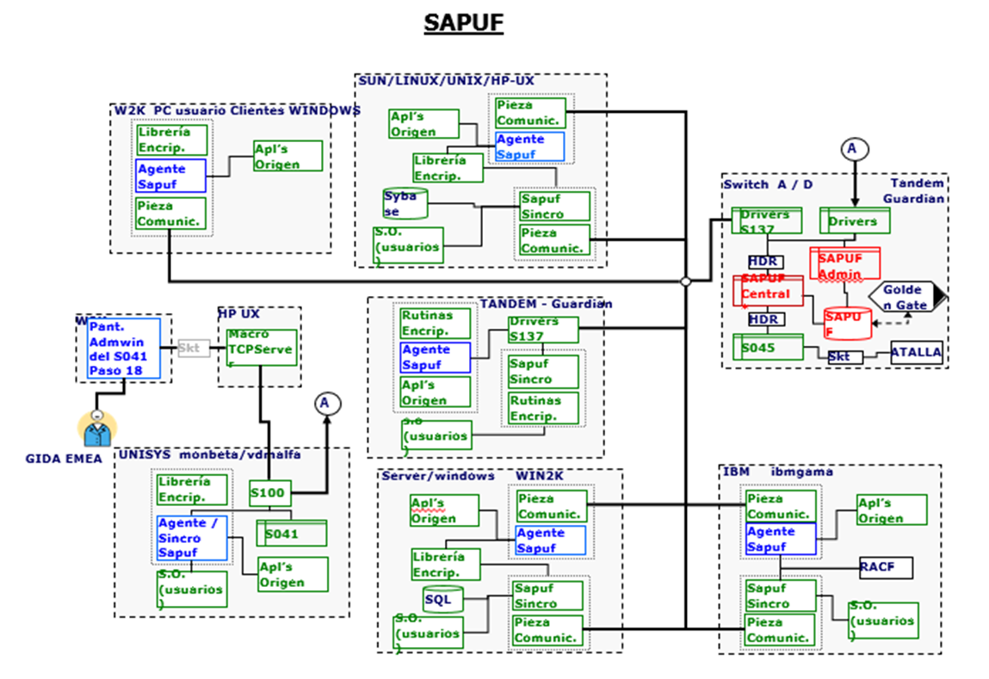

## **5.2 Business Rules**

### **Business Rule**

There are no business rules for this project

## **Business Requirements \***

### **Business Functions and Process Descriptions \***

RU-0001 - Grouping accounts and applications to be migrated - The system must generate in T the file with pre-selected accounts and applications to be migrated

RU-0002 - Provide segregation of duties between user accounts. - Configurable policies that enable organizations enforce granular privileged access controls, automate workflows and rotate passwords at a regular cadence without manual intervention.

RU-0003 - Initiate onboarding with request to integrate with CyberArk AIM - Applications must satisfy prerequisites before onboarding.

RU-0004 - Configuration Files for Application Server - There is default central configuration file main_appprovider.conf.<platform>.<version> created whenever Credential Provider (CP) is installed in Windows or Linux servers This file can be uploaded to Safe AppProviderConf through PrivateArk Client.

RU-0005 - Create CP User and generate initial credential file per app server. - CyberArk Administrator do by running CreateCredFile utility, generate appprovideruser.cred file, and circulate that file to the application team.

RU-0006 - Securely provide initial cred file to the application team - step need to be managed by application team, application team can run this utility in their environment after installing the credential provider agent.

RU-0007 - Configure Parameters file , install, RPM , Vault.ini , initial cred file - Configure parameters and start AIM Service for connect to CyberArk Vault and execute password reset on CP User and CP updates password in initial cred file.

RU-0008 - Create application user and authentication parameters - Application user must have OS user, path and authorized machines specified.

RU-0009 - Grant Application and CP Users retrieval access to the FID safe - GIDA will be grant access to the FID Safe.

RU-0010 - CP synchronizes passwords to local cache based on persistence settings - Configure application user account password policy to meet Citi’s standards.

RU-0011 - Application will be ready for password retrieve - CMP initiates FID Account take over through password reset.

RU-0012 - Provide a detailed audit log that captures all activities of both functional and non-functional users. - Log below significant security administration events such as user creation, user access rights modification, password reset, security configuration changes.

RU-0013 - Log Messages - To capture the following items in the log messages: 1) Appropriate timestamp (date, hours, minutes, seconds), 2) User ID and Event type, affected resource, access type, action outcome.

RU-0014 - Log Events - Ability to capture the following events in the log: authentication events, unsuccessful login, successful login if requires to support forensic purpose, account lockouts, significant security administration events, user/group creation, creation of application roles/profiles, modification of roles/profiles, modification of user access rights, manual password reset, infrastructure security related events, changes to system security configuration, manual change to the non-security related configuration which effects service function, log integrity events, manual log deletion of stoppage and manual log modification.

### **Business Requirements (1..n) \***

n/a

## **CITMS Mandatory Business Requirements \***

### **Reporting \***

RU-0012 - Provide a detailed audit log that captures all activities of both functional and non-functional users. - Log below significant security administration events such as user creation, user access rights modification, password reset, security configuration changes.  
RU-0013 - Log Messages - To capture the following items in the log messages: appropriate timestamp (date, hours, minutes, seconds), user ID, event type, affected resource, access type and action outcome.  
RU-0014 - Log Events - Ability to capture the following events in the log: authentication events, unsuccessful login, successful login if requires to support forensic purpose, account lockouts, significant security administration events, user/group creation, creation of application roles/profiles, modification of roles/profiles, modification of user access rights, manual password reset, infrastructure security related events, changes to system security configuration, manual change to the non-security related configuration which effects service function, log integrity events, manual log deletion of stoppage and manual log modification.

### **Interface \***

RU-0004 - Config Files for App Server - There is default central configuration file main_appprovider.conf.<platform>.<version> created whenever Credential Provider is installed in Windows or Linux servers This file can be uploaded to Safe AppProviderConf through PrivateArk Client.

RU-0005 - Create CP User and generate initial cred file per app server. - CyberArk Administrator do by running CreateCredFile utility and generate appprovideruser.cred file and circulate that file to the application team.

RU-0006 - Securely provide initial cred file to the application team - step need to be managed by application team , application team can run this utility in their environment after installing the credential provider agent.

RU-0007 - Configure Parameters file , install, RPM , Vault.ini , initial cred file - Configure parameters and start AIM Service for connect to CyberArk Vault and execute password reset on CP User and CP updates password in initial cred file.

RU-0008 - Create application user and authentication parameters - Application user must have OS user, path and authorized machines specified.

RU-0009 - Grant Application and CP Users retrieval access to the FID safe - GIDA will be grant access to the FID Safe

RU-0010 - CP synchronizes passwords to local cache based on persistence settings - Configure application user account password policy to meet Citi’s standards.

### **Legal, Regulatory, Compliance, Anti-Money Laundering and Records Management Requirements \***

It does not apply; it is a technology project, only about to replace a security legacy component to a new standard in Citibanamex



#### Accessibility Requirements

​ It does not apply; it is a technology project, only about to replace a security legacy component to a new standard in Citibanamex.

### **User Testing Requirements \***

RU-0007 - Configure Parameters file , install, RPM , Vault.ini , initial cred file - Configure parameters and start AIM Service for connect to CyberArk Vault and execute password reset on CP User and CP updates password in initial cred file.

### **COB Recovery Requirements \***

Replicate production CyberArk component on the COB environments, this is a global infrastructure.

### **Data Transfer \***

It does not apply; there is not any data transfer consider on the project. It is only about to replace a security legacy component to a new standard in Citibanamex and CyberArk does not transfer customer data.

**List of UAT Stakeholders (Organizations which will perform UAT) \***

1. ESCOBAR JANTES, JULIO (JE59148) [145791,145759]
2. TONGO RIVERA, BEATRIZ (BT56405) [163929]
3. HILERIO ALFARO, JOSE FERNANDO (JH37855) [145796]
4. PINEDA TORRES, ALEJANDRO (AP87831) [159127]
5. TOVAR ESCOBAR, LUIS MANUEL (LT37931) [165699]
6. RODRIGUEZ GOMEZ, MIGUEL (MR39423) [147983,147984,151630]

### **Perform Production Parallel Testing \***

It does not apply; there is not impact on the applications performance. It is only about to replace an agent to manage the FID password.

### **Perform Production Assurance Testing (PAT) \***

NO

### **Data Requirements \***

RU-0012 - Provide a detailed audit log that captures all activities of both functional and non-functional users. - Log below significant security administration events such as user creation, user access rights modification, password reset, security configuration changes

RU-0013 - Log Messages - To capture the following items in the log messages: appropriate timestamp (date, hours, minutes, seconds), user ID, event type, affected resource, access type, action outcome.

RU-0014 - Log Events. Ability to capture the following events in the log: authentication events, unsuccessful login, successful login if requires to support forensic purpose, account lockouts, significant security administration events, user/group creation, creation of application roles/profiles, modification of roles/profiles, modification of user access rights, manual password reset, infrastructure security related events, changes to system security configuration, manual change to the non-security related configuration which effects service function, log integrity events, manual log deletion of stoppage and Manual log

### **Are there any Cross Border Data Privacy Implications with this project? \***

No, not required.

### **Security Requirements**

RU-0009 Grant Application and CP Users retrieval access to the FID safe - GIDA will be grant access to the FID Safe.

RU-0010 CP synchronizes passwords to local cache based on persistence settings - Configure application user account password policy to meet Citi’s standards.

RU-0011 Application will be ready for password retrieve - CMP initiates FID Account take over through password reset.

## **Business UI Screens**

**Business UI Screen**

|  |  |  |
| --- | --- | --- |
| CSI ID | NAME | Architecture Diagram |
| 145791 | TARJETA CORPORATIVA. (C430) |  |
| 163929 | Integral Process of Technical Dictamination |  |
| 145796 | SIAF (FRAUD CONTROL AND MANAGEMENT) |  |
| 145759 | Embossing and Delivery System (C104) |  |
| 159127 | CSIS-Mexico Security - Alarms and Video Monitoring System |  |
| 147984 | Fiduciary Fess Application |  |
| 151630 | Bussinesses Control System and Treasury |  |
| 147983 | Trust Digital Files |  |
| 165699 | Account receivable discount web |  |

## **Other Business Diagrams**

Any additional diagrams that will enhance the understanding of the business requirements.  If there are no business diagrams you can add a statement to the folder description "There are no Other Business Diagrams for thie project."

Add additional diagrams in this folder

Trace Requirements:

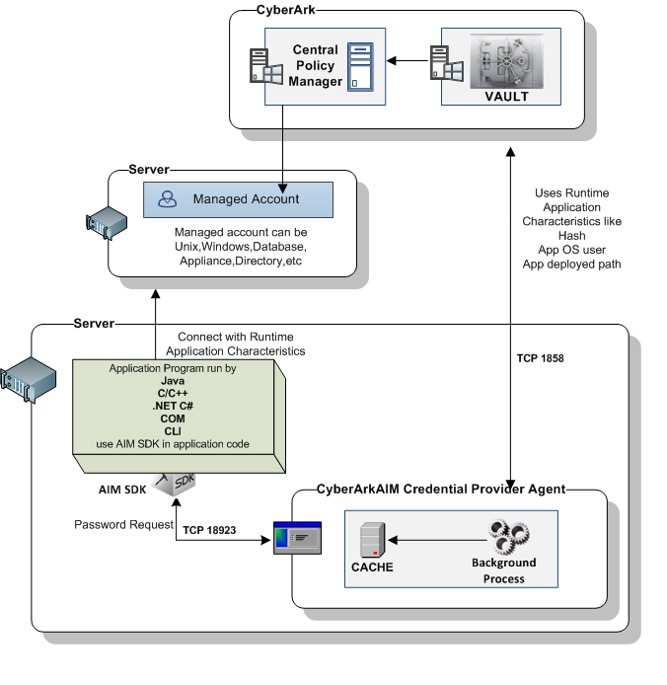

# Glossaries

* 1. **Glossary of Acronyms**

| Acronym | Description |
| --- | --- |
| FID | Functional ID |
| SAPUF | Sistema de Administración de Passwors de Usurios Funcionales |

* 1. **Glossary of Terms**

| Term | Description |
| --- | --- |